Course: CSC14003 – Introduction to Artificial Intelligence

Class 22CLC – Term II/2023-2024

MIDTERM EXAMINATION REVIEW

Q1. The three couples problem. Three couples are on a safari, when they come to a river. The only way for them to cross is with a small rowboat which can only accommodate two people at a time. Complicating the process is the fact that the women are all the jealous type and refuse to leave their significant other in the presence of another woman unless she is there as well. How can the couples cross the river without any romantic strife?
Consider a state as a tuple of values. Which values should be included in the tuple?

From this point, answer the following questions according to the definition of a state above.
Define the initial state and the goal state.
What is the path cost?
What is the maximum number of states in the state space, i.e., including illegal states? Explain.

Q2. Consider the following graph. The initial state is marked with a BLUE circle, and the goal state is marked with a RED circle. Ties are broken in alphabetical order. | 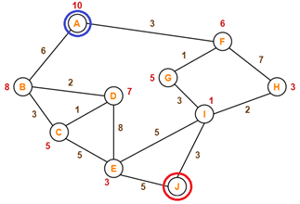
For each of the following search strategies, state the order in which states are expanded and the path returned. Vertices should be presented in their exact order.
Note that the path returned will not be accepted if the list of expanded states is wrong.
Algorithms | List of expanded states | Path returned
Breadth-first search
Uniform cost search
Depth-first search
Greedy best-first search
Graph-search A*

Q3. Consider the 8-puzzle problem. Apply the hill-climbing algorithm with Manhattan distance heuristic to find a solution for the following pair of initial and goal states.
Initial state | 2 8 3  1 6 4  7 - 5 | Goal state | 1 2 3  8 - 4  7 6 5
Your work should address the following requirements.
- Draw the search tree including all possible successors of expanded states (except the goal)
- Calculate the heuristic value for every node
- Mark the optimal strategy found
Q4. Consider the 4-bishops problem. Every state of the problem has 4 bishops on the board, each of which is in a separate column.  Answer the following questions: | 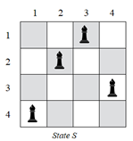
What is the total number of states in the state space? Explain.
Each step of the search moves a bishop within its own column. How many successors can a state generate? Explain.
Each state of the problem can be represented in the genetic algorithm as 4 digits, each indicating the position of a bishop in that column. For example, S = 4213.
Let n_{b} be the number of attacking pairs of bishops of state n.
Define the fitness function for a state n:
The current generation includes 4 states: S1 = 2341; S2 = 2132; S3 = 1232; S4 = 4321.
Calculate the value of Fit(n) for each of the 4 states and the probability that each of them will be chosen in the “selection” step.
State n | S1 | S2 | S3 | S4
Fit(n)
Prob(n)

Q5. Consider the following game tree. Assume that the root node corresponds to the MAX player and the search always visits children left-to-right.
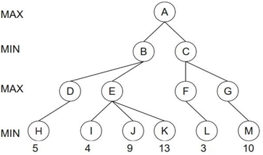
Compute the final backed-up computed by minimax algorithm. (No alpha-beta pruning at this step)
A | B | C | D | E | F | G
Compute the final backed-up computed by alpha-beta pruning. If a node is pruned, mark X.
A | B | C | D | E | F | G
Using the minimax calculations from part a), without performing any alpha-beta calculation, rotate the children of each node in the above tree at every level to ensure maximum alpha-beta pruning. Fill in the nodes with the letter of the corresponding node. Draw the new edges.
Q6. This problem asks about the Map coloring problem. Each region must be colored one of Red (R), Green (G), or Blue (B). Neighboring regions must be of different colors.  Note that the following questions are mutually independent. | 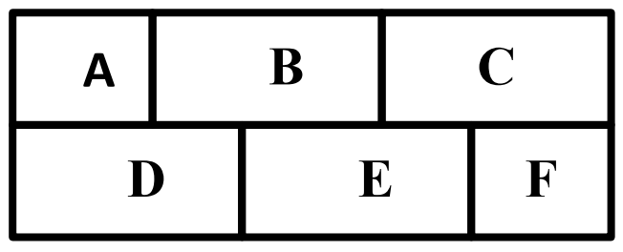
Cross out all values that would be eliminated by Forward Checking, after variable B has been assigned as shown.
A | B | C | D | E | F
R G B | R | R G B | R G B | R G B | R G B
A and B have been assigned values as shown, but no constraint propagation has been done. Cross out all values that would be eliminated by Arc Consistency AC-3.
A | B | C | D | E | F
R | G | R G B | R G B | R G B | R G B
Variable A is already assigned, and constraint propagation has been done. Circle all unassigned variables that might be selected by the Minimum-Remaining-Values (MRV) Heuristic.
A | B | C | D | E | F
R | G B | R G B | G B | R G B | R G B
Variable A is already assigned, and constraint propagation has been done. Circle all unassigned variables that might be selected by the Degree Heuristic.
A | B | C | D | E | F
R | G B | R G B | G B | R G B | R G B
Assume no variables have been assigned yet, solve the CSP using backtracking with forward checking. Ties (after considering all necessary heuristics) are resolved by lexicographical order.
Note: for every step, present the MRV values for all regions that are not colored yet. If there are many regions that have the same minimum MRV, present the DH values for these regions.
Step 1
Variables | A | B | C | D | E | F
MRV
DH
Assign to the variable ____________________ with the value ______________________________

Step 2
Variables | A | B | C | D | E | F
MRV
DH
Assign to the variable ____________________ with the value ______________________________
Step 3
Variables | A | B | C | D | E | F
MRV
DH
Assign to the variable ____________________ with the value ______________________________
Step 4
Variables | A | B | C | D | E | F
MRV
DH
Assign to the variable ____________________ with the value _______________________________
Step 5
Variables | A | B | C | D | E | F
MRV
DH
Assign to the variable ____________________ with the value ______________________________
Step 6
Assign to the variable ____________________ with the value ______________________________

Q7. You wake up early in the morning, full of excitement and anticipation, so you decide to dress up very specially. After a while you have narrowed down the choices for each of the four items of clothing, (H)eadwear, (B)odywear, (L)egwear, and (A)ccessory as follows:
- H ∈ { hat, cap }
- B ∈ { shirt, blouse, jumper }
- L ∈ { leggings, skirt, trousers }
- A ∈ { scarf, tie, cravat }
Furthermore, you have derived the following constraints:
- If you choose the jumper, the cap is the only matching headwear.
- The leggings do not go together with the hat.
- If you wear a shirt or a blouse, then you have to take a tie or a cravat.

Formulate the problem as a CSP, stating the variables and corresponding domains.
Variables
Domains
Binary constraints:

Draw the constraint graph associated with your CSP, in which each node represents a variable and an edge connecting two nodes represents the relation between the two variables denoted by these nodes.

Now, assume that you decide to take the hat. What can you deduce about your other clothing? Cross out eliminated values to show the domains of the variables after arc consistency has been enforced.
Variables
Domains

